Back to the Institute of Botany & MetaCentrum, usage of the computing resources.

Work on the cluster
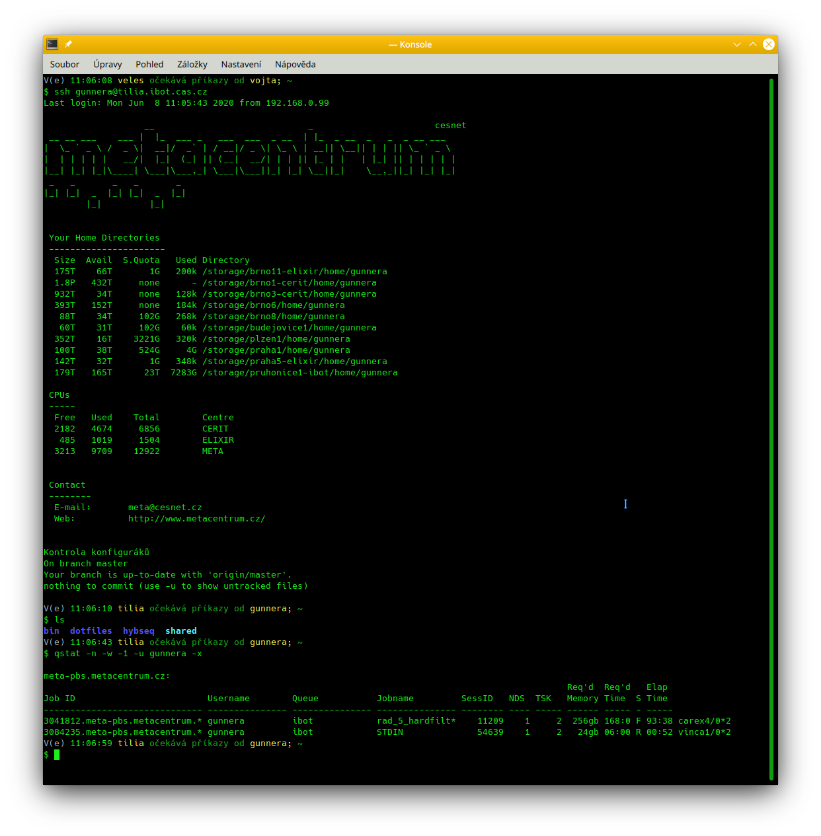
Basic information about work in MetaCentrum are in its documentation. Prior you start work on MetaCentrum, reads its documentation and learn how to work in Linux command line.
MetaCentrum, and therefore the Průhonice cluster, run in a Linux environment (users log in via SSH), which implies that users must master the basic UNIX commands in order to interact with the operating system. The user must prepare in advance a script containing all commands and operations that will be performed during the analysis. The job is executed by submitting the script with the qsub command.
To submit a job to a queue on our cluster the user must add to the qsub command the -q ibot parameter. The node on which the computations will be carried out can be specified such as -l cluster=carex, -l cluster=draba or -l cluster=vinca. Other parameters are available and can be obtained from the qsub assembler tool. E.g.:
# Login to fronend
ssh USER@tilia.ibot.cas.cz
# Prepare task...
# ...and run it:
qsub ... -q ibot ...
qsub ... -l select=...:cluster=carex -l -q ibot ...
qsub ... -l select=...:cluster=draba -l -q ibot ...
qsub ... -l select=...:cluster=vinca -l -q ibot ...
qsub -l walltime=1:0:0 -q ibot -l select=1:ncpus=4:mem=4gb:scratch_local=1gb -m abe script.sh
Although all the machines support hyperthreading, the queuing system can only manage physical cores. If the user wants to take advantage of hyperthreading, she needs to book the entire node on which the analysis will be carried on, e.g. something like:
qsub -l walltime=1:0:0 -q ibot -l select=1:ncpus=8:mem=500gb:scratch_local=5100gb:hyperthreading=True:cluster=carex -l place=exclhost -m abe skript.sh
qsub -l walltime=1:0:0 -q ibot -l select=1:ncpus=80:mem=1500gb:scratch_local=5100gb:hyperthreading=True:cluster=draba -l place=exclhost -m abe skript.sh
qsub -l walltime=1:0:0 -q ibot -l select=1:ncpus=16:mem=500gb:scratch_local=5100gb:hyperthreading=True:cluster=vinca -l place=exclhost -m abe skript.sh
Important parameters are hyperthreading=True and -l place=exclhost reserving entire servers. The queueing system then does not prevent the analyses to exceed the requested CPU resources, which consequently enables the use of hyperthreading.
Users without sufficient knowledge of work in Linux command line should start by studying, e.g. Course of work in Linux command line not only for MetaCentrum of Vojtěch Zeisek.

See further access to the computing cluster of IBOT for employees and collaborators.

